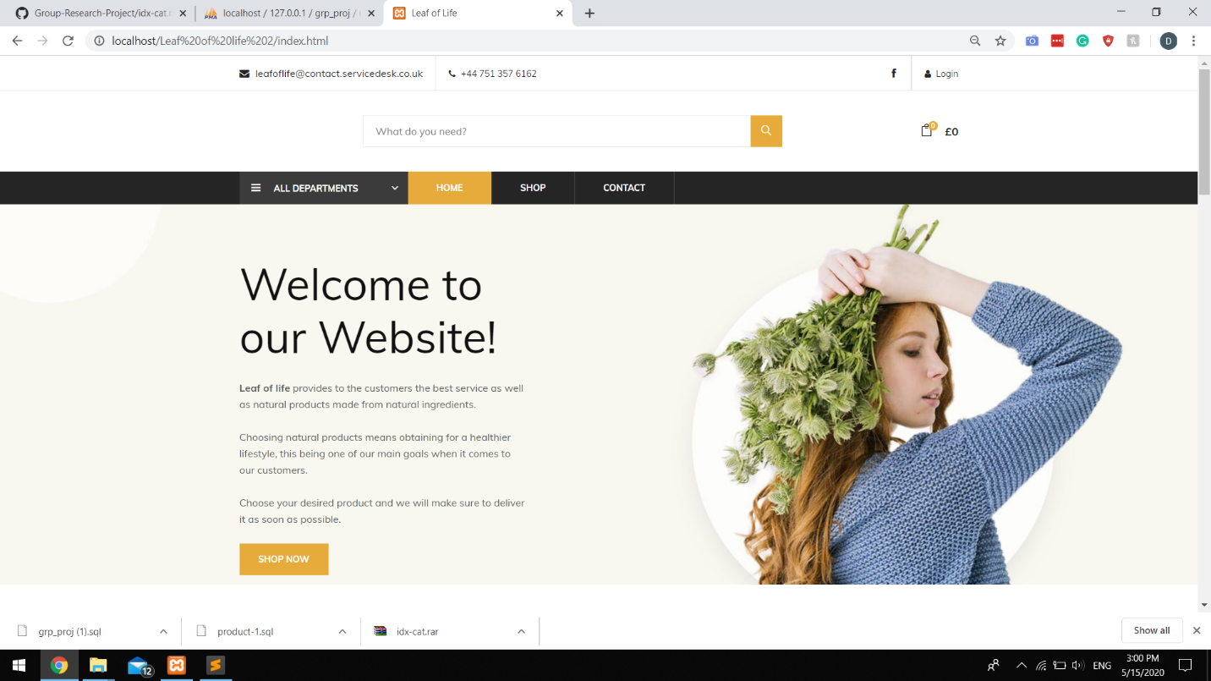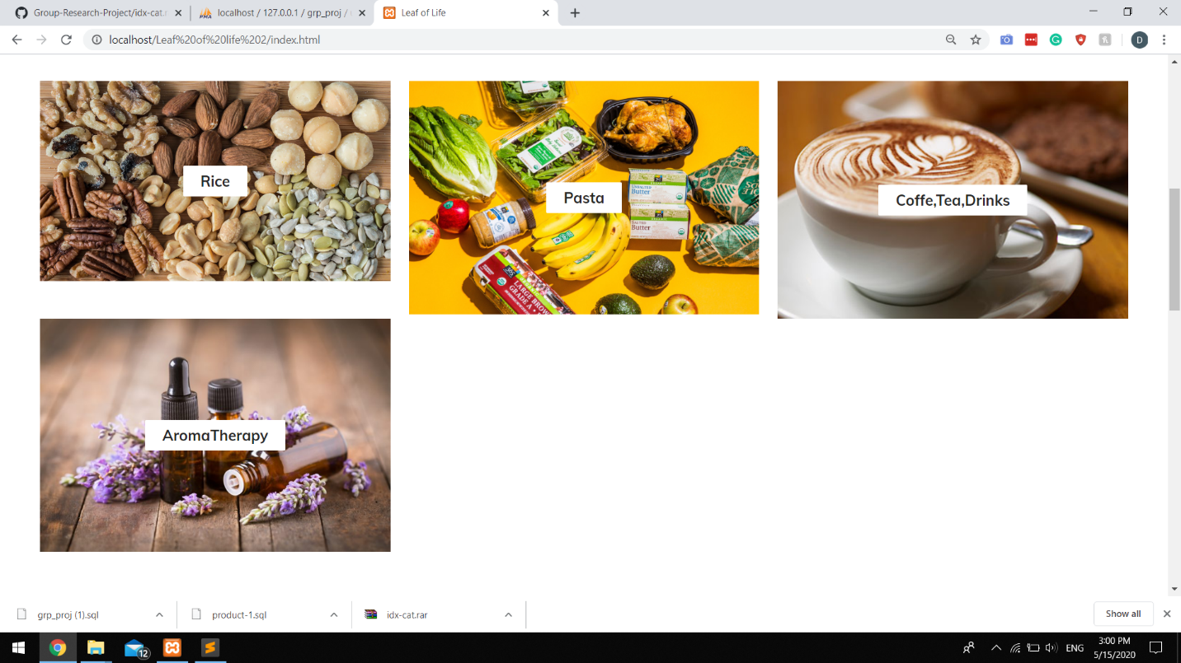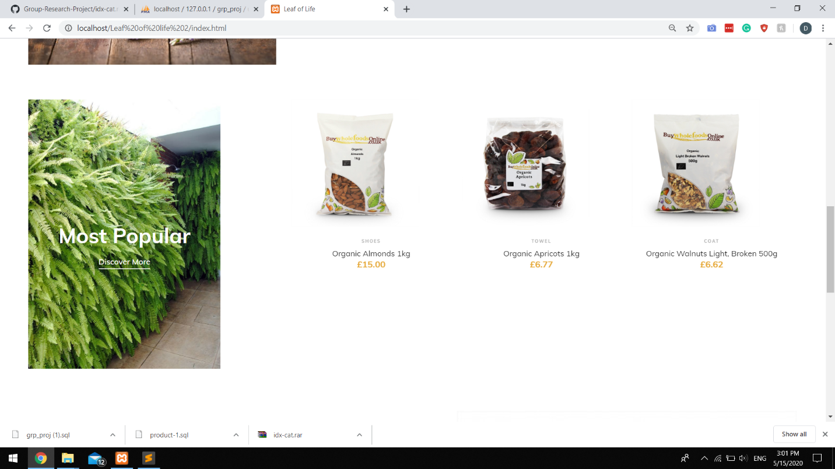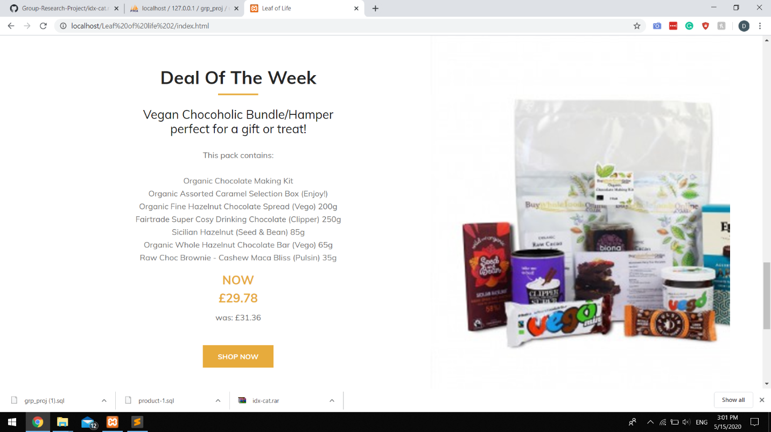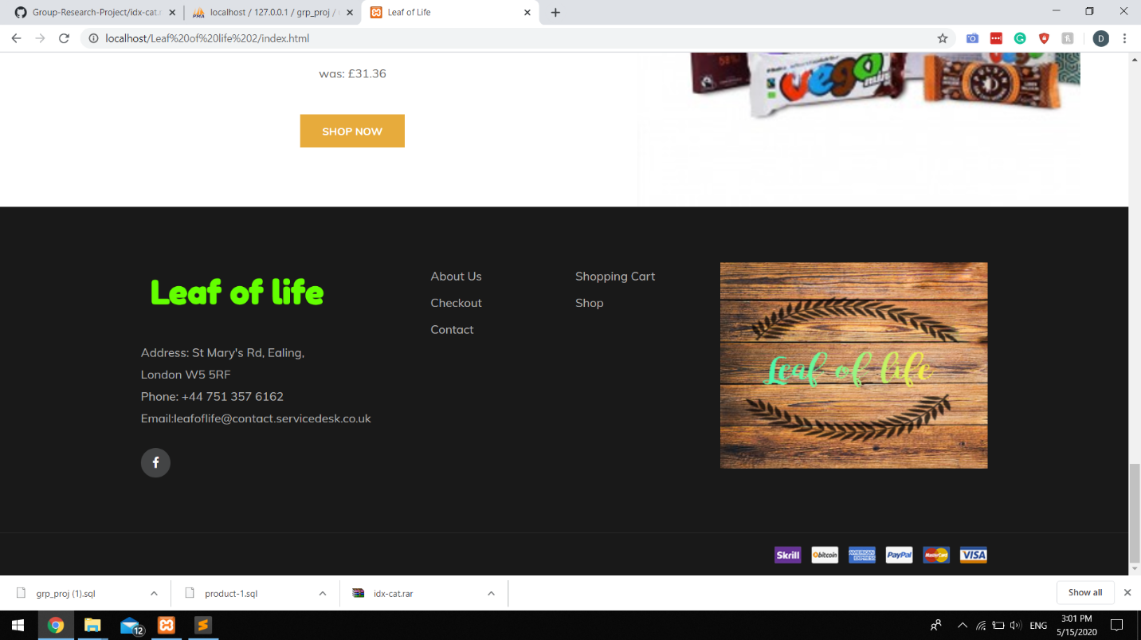

This is our welcome page,in this you will find some words about who we are and why we are doing this, all the categories you can choose to shop from, a way to get to us(contact),deal of the week, login button that redirects you to the login page.



The section in the red box is called “header”

The following section in the header is creating the login and facebook buttons in the top right corner

Once you click on the login button you will be redirected to “login.html” using the href function

\*because we are using a template all the classes that we are using are located in the css files, most of them have been modified\*

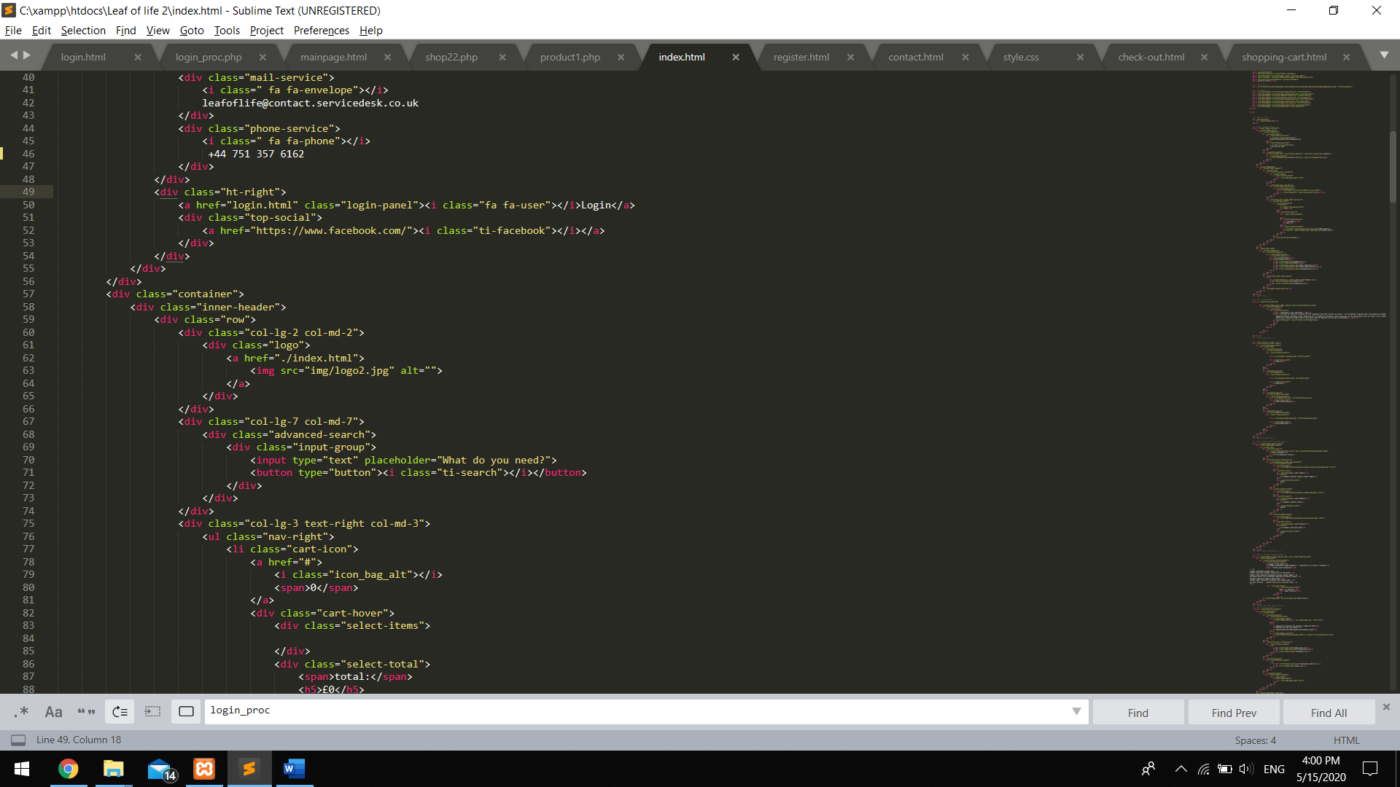

In this section of code we are creating the navigation bar:

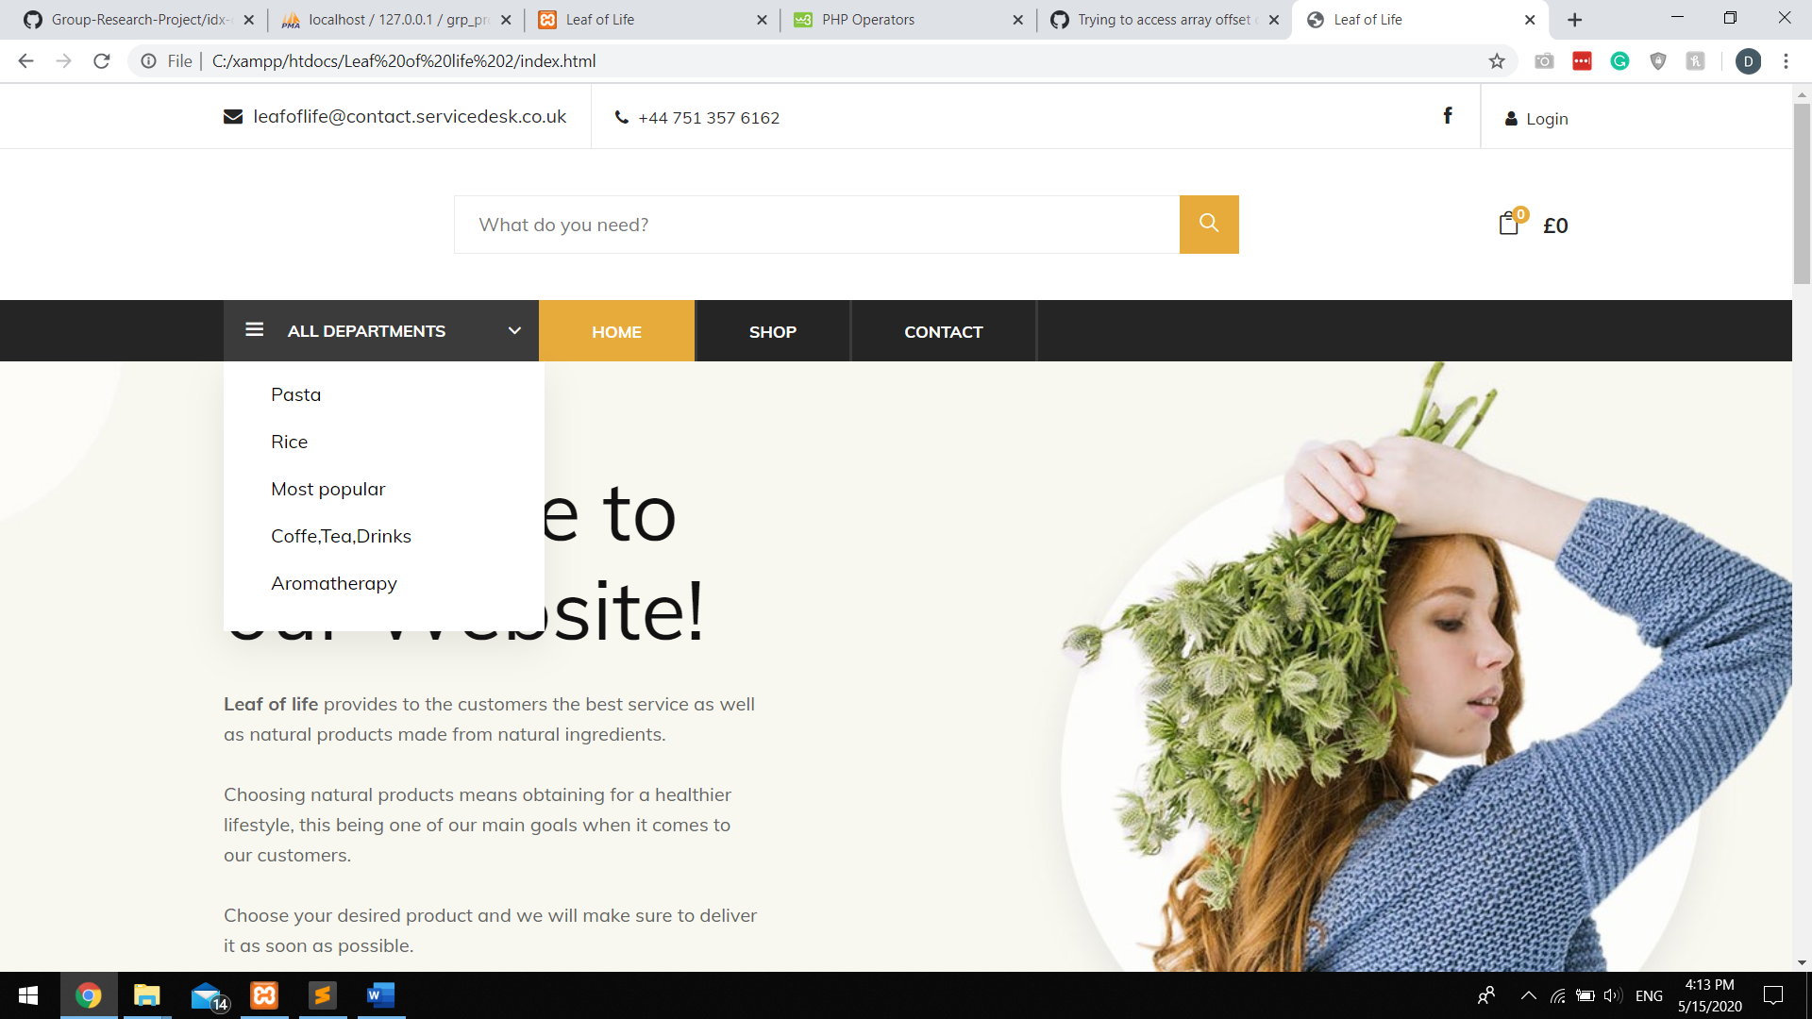

Once your mouse will be on the “All departments” tab, a list will be shown under it with all the possible categories our site provides

In the code:

We are linking each category with a separate php file special created for the category with the details provided straight from our database.

Once you click on any other option such as shop or contact, you will be sent to the page between the brackets in href=”…”

A class is considered active if that page is the one that you re visiting right now. For example here :Home

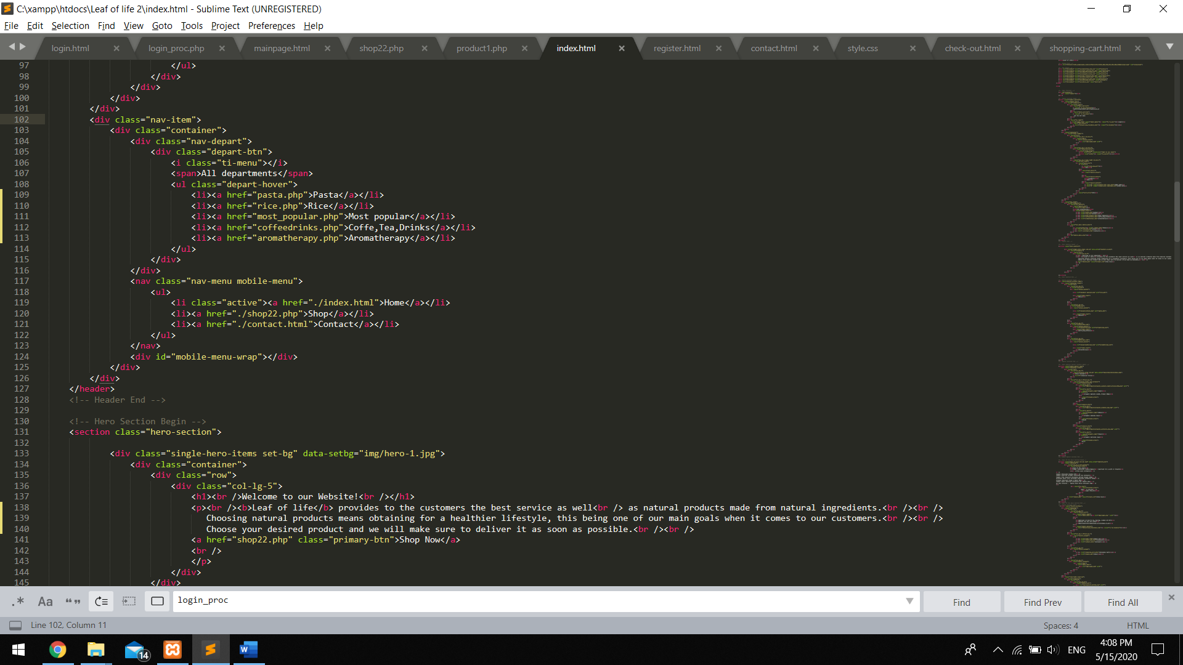

Up next are the categories

If you click on any of this photo you ll be sent to a separate page where you will see only the products that are included in the chosen category.



In here we are doing the same thing with the reference page for each category, only just adding some photos and using some css functions.

